Content Marketing and Social Media Improvement Plan:

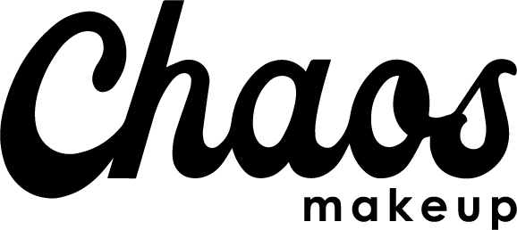

Chaos Makeup
Beauty/Health
ChaosMakeup.com
Hover for Social Media Accounts:



Marketing Audit

Desired Content Marketing Status

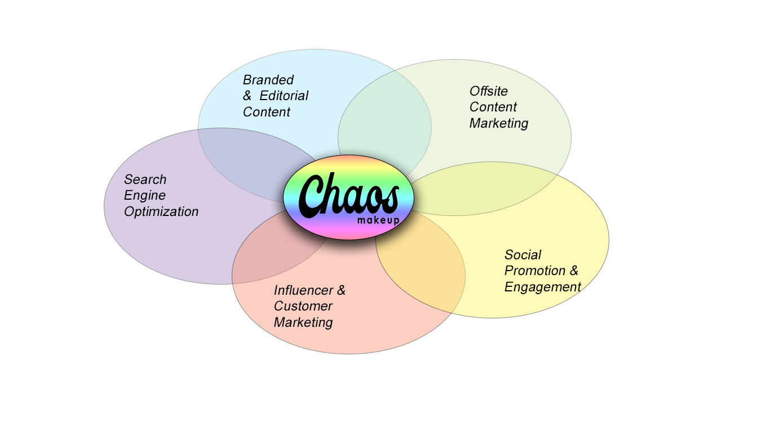

Current Content Marketing Status
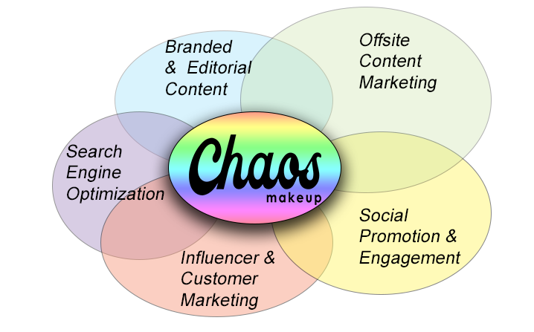

Summary Suggestions

Current | Suggested Improvement
Offsite Marketing
Too Passive – Products fall into several natural beauty categories that are not being mentioned offsite | Take active measures by producing content on other eco-friendly/vegan/cruelty friend web spaces
Too Passive – Bloggers are reviewing product without knowing products story | Explain on website that product is eco friendly, cruelty free, vegan and hand made, that offsite reviewers have a better understand when reviewing products
Company strong points are not marketed onsite
Branded and Editorial Content
Company has nothing but products for sale hosted on website | Create pages to host information about the branding of the company
Company has nothing about company founder on website | Create pages on Chaos Makeup to explain the story of the brand creator
Company has nothing on the website to explain each product is hand crafted | Create a webpage that explains at a high level how each product is produced per order
Social Media
Multiple Instagram accounts | Delete the less popular Instagram account
Social media pages are linking to the various social media accounts owned by the company | Direct all traffic to the company’s website, ChaosMakeup.com
Facebook is the most active site for the brand | Produce content first on Facebook and allow Facebook to push the content through to Instagram
Influencer and Customer Marketing
Company has been endorsed by top publications but has small social media following | Reach out to influencers with samples of products and ask for reviews
 | Once company website creates a blog, build relationships with other bloggers and allow them to guest post on company’s blog
Company frequently speaks with audience about new products to be launched | Send products back to industry leaders who have already written about the brand and pre pitch launch of new product
Search Engine Optimization
Company’s website hosts only super detailed product descriptions | Add content webpages to website and optimize each page
Site’s top keywords are not industry related | Incorporate competitor’s keyword (which are more specific to makeup industry) into website
Update title tags and meta descriptions | Too short. Use these as opportunity to introduce those new keywords
Add the following pages | About ChaosMakeup, Meet Megan Martinez, FAQ – All About Vegan, Cruelty Free, EcoFriendly Beauty, and a beauty blog

Detailed Analysis

Offsite Content Marketing

Current Offsite Marketing

ChaosMakeup has received attention from a number of industry leaders in the beauty domain resulting in a plethora of authoritative sites linking back to the company’s social media pages (Bustle, Refinery 29, Vogue, Allure, PopSugar etc ).

Vogue magazine is often considered the pinnacle of prestige in the fashion and beauty industry. In May of 2017, the publication’s subsidiary Teen Vogue published a feature piece highlighting the company’s flagship Kaleidoscope Rainbow Highlighter.

Allure magazine is also a major beauty magazine in the United States. Allure, like Vogue, followed suit publishing two pieces praising the beauty brand for its superior quality of color pigmentation when compared to other make up brands producing the same product.

The company allegedly went viral when a beauty blogger discovered the company online and left a rave review on the social media platform Reddit. A simple Google search of the makeup brand results in a litany of beauty-bloggers, eager to leave their own personal reviews (some good, some bad) of the independent beauty company.

The world is talking about ChaosMakeup….

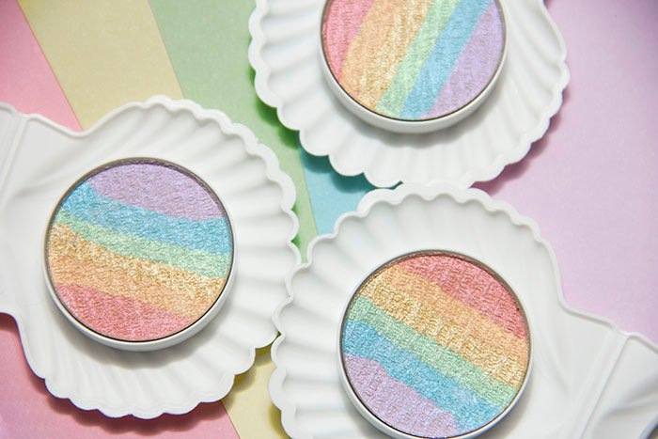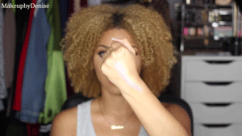
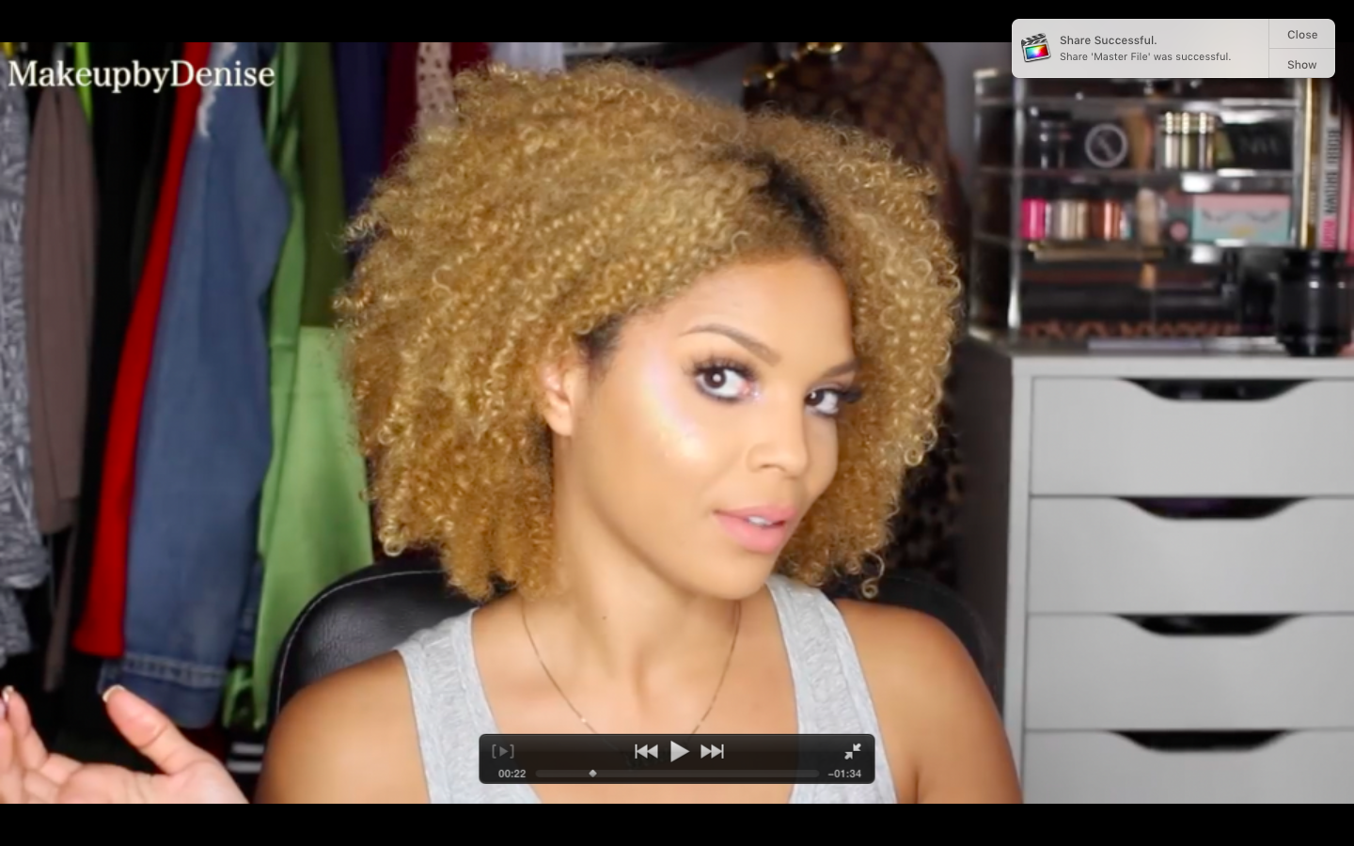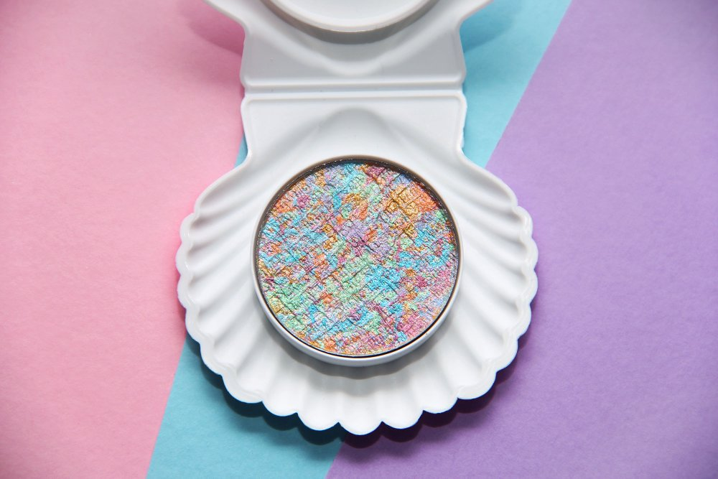

Link to Product In Motion

Upgraded Content Marketing Suggestions:

Given the volume of big name companies linking back to ChaosMakeup’s social media sites, you would think there would be little need for improvement in this
arena, yet there is plenty.

Chaos Makeup, while excelling in offsite content has done so through passive means.

The indi-beauty company is producing stellar products that people are praising, yet the brand has only 178 backlinks to its website.

Given the influence of some of the industry leaders praising this company, that is way too small.

The brand has great a reputation, but little visibility.

So what can ChaosMakeup do?

My suggestion would be to follow the example Seventh Generation. Unless you deep dive into some of the descriptions of ChaosMakeup’s products, you would never know that each of the products the brand produces are hand crafted, vegan, cruelty free, and eco friendly.

The State of Texas, Congress, and a number of organizations have acknowledged the brand’s creator, Megan Martinez for her humanitarian and animal rescue efforts. If ChoasMakeup made an effort at producing offsite, or even anchor content, in these arenas they could instantly grow their site’s traffic and back linkage.

While I did mention above, the company has been reviewed by a number of beauty bloggers, I noticed consistently while many bloggers praised the brands products, they complained about the pricing. This is a direct result of under marketing the origin of the products and taking this sort of passive roll in controlling their offsite content.

Eco-friendly, vegan, cruelty free, artisan – in addition to being noble, these themes also happen to be major trends right now in the beauty industry. ChaosMakeup is missing out on major opportunities by not guest posting, or reaching out to eco friendly specific bloggers, like SeeShopLove or the Organic Beauty to produce reviews or host guest content.

Last, and this may be more of an SEO improvement, the Teen Vogue article and both the Allure articles link not to ChaosMakeup’s website, but rather to the company’s primary Instagram account. This needs to be corrected. Even if these pieces were published before the indi brand set up their website, a simple email to the writer or editor who worked with ChaosMakeup on these pieces can correct this traffic blunder.

The official ChaosMakeup website needs to be the anchor for the brand. The company’s Instagram, while full of exceptional content, is not where you should want to drive an interested consumer. Send them directly to the purchasing source.

Branded and Editorial Content

Chaos Makeup is doing little work in this arena.

If one were to navigate to the company’s website, you will notice immediately there are zero content focused pages.

In researching the brand, I found the company’s Facebook page to be most informative about the company’s creator, her causes and her passions. I found the Teen Vogue and Allure articles to be most informative about the nature and quality of the products.

Upgraded Content Marketing Plan

All of this content needs to be anchored on the brands website. That’s not to say the owner should repost those articles there, but rather the company should have feature pages, such as an, About section, and an FAQ section on being eco friendly, cruelty free and vegan.

While I’m sure Megan Martinez has no intention of revealing her process for making her makeup, there are ways she could do an introduction video which introduces her to her customer and give a high level presentation of her product and artistic process to her consumers.

As mentioned above, the company has a stellar reputation but low visibility. Industry leaders such as Vogue and Allure are supplying direct links to the company’s website, yet the site operates as nothing more than a catalog of the brand’s products. That being said, thorough descriptive descriptions are given to each product .

If this brand wishes to grow , there are many approaches they can take in this arena.

Social Media and Promotion

ChaosMakeup is actually doing an exceptional job in this arena.

On Facebook, the company consistently shares inspiring posts, interacts with users, posts videos of their products in use, and hosts give-aways and contests.

The company also has two Instagtram accounts. The first one is @ChaosMakeupArtist and the second and primary page is @ChaosMakeup. Both Instagram accounts are active, posting daily stills and video content of how the products work and interacts in different lighting.

Their video content receives roughly 4x the social media engagement (likes/comments) as their still photos content. If content quality and social media interaction are the cornerstones of successful marketing we can give ChaosMakeup an A+ for their efforts.

While the company is doing exceptional, let’s talk improvement.

Upgraded Social Media Improvement Plan

As mentioned above, while the primary Instagram account has nearly 160 thousand followers, I think that is low considering the amount of press the brand has received.

The first and biggest thing ChoasMakeup should do to boost their social media presences, is eliminate the account @ChaosMakeupArtist. When bloggers and publications are linking back to Chaos, they are linking back to different locations.

Most of the offsite content I found, linked directly to the company’s primary Instagram. A few linked back to ChaosMakeupArtist on Instagram, and beauty bloggers are linking to a mix of all three, but namely to the company’s website.

The chart below shows the company’s social media accounts, where they are directing traffic to, and the number of followers each account has.

Facebook | @ChaosMakeupArtist | Links to Instagram @ChaosMakeup | 205,203 Likes,  202,884 Follows
Instagram | @ChaosMakeupArtist | Links to Instagram @ChaosMakup | 1158 Followers
Instagram | @ChaosMakeup | Links to www.ChaosMakeup.com | 158,000 Followers
Website | www.ChaosMakeup.com | Links to @ChaosMakupArtist on Instagram | N/A
Instagram | _MeganMartinez | Links to Instagram @ChaosMakeup  Links to Snap Chat Chaos_Makeup | 5055 Followers
SnapChat | Chaos_Makeup | N/A | Not Active

These sites are forming a bizarre rabbit’s hole of links. Each one should operate solely under the name @ChaosMakeup (with the exception of Megan Martinez’s personal account) and each should only link back to the company’s website, www.ChaosMakeup.com .

Let’s talk OPA .

OPA is not a legendry rap track by Naughty by Nature. OPA stands for Other People’s Audience and is a marketing practice used to tap into influencers’ audiences to bring new individuals to your own audience.

ChaosMakeup is most active on Instagram but according to a social media SEO tool, it is most engaged with through Facebook, which is also where the site has the most followers. Given their product is highly pigmented color changing makeup, Instagram may seem like the correct social media platform for them, however, sharing is not a native part of the Instagram platform. Their help center explicitly advises against directly sharing other people’s content and if you Google Instagram sharing, you will literally find blog posts on the general process of receiving permission and the technical steps to share another person’s posts. It’s not a one click and done process. That being said, it is rather simple to link a Facebook account to an Instagram account. ChaosMakeup should shift posting activities to Facebook, where they are more popular, and have their video and photographic content subsequently shared on Instagram through pushing. The social engagement element however should continue on both platforms.

Given that ChaosMakeup has exceptional quality content, exceptional quality products and is making news with industry legends, the next big step is to engage with social media influencers to tap into their audiences.

Influencer and Customer Marketing

On both Facebook and Instagram, Megan Martinez, the creator and owner of ChaosMakeup, whom I imagine is running their social media, is very engaged with her followers- speaking directly to them, complimenting their usage of her products and giving them previews of her new products upon request. When it comes to interaction, ChaosMakeup has this portion of their marketing strategy covered. So now we’ve reached the big piece of their marketing content that I believe is missing, which is interaction with industry influencer.

Upgraded Social Media and Marketing Influencer Improvement Plan

Chaos Makeup has a new product coming out. According to Allure, their rainbow highlighter broke the Internet when it hit Reddit in 2017. Currently, the company is producing a new version of the product, which has a holographic quality to it. This is a major marketing opportunity and a great chance to both

1)Pre-pitch to media and bloggers
With this new holographic highlighter coming out, the company may want to
reach back out to Refinery29, PopSugar, Teen Vogue, Allure and give them the scoop on this product. If the actions suggested in this marketing report are taken, this release could almost be treated as a soft re-launch for the brand and bring a wave of new members to both their social media audience and consumer group.

2) Engage with Industry Influencers
James Charels – Makeup Artist - 3.1 million followers
Chrisspy – Makeup Aritist - 3.8 million followers
Amra Olevic – Model turned Makeup artist 5.4 million followers.
SeeShopLove – Natural Beauty and Subscription Review Site – top review blogger when searching natural beauty product reviews
Organic Beauty Blogger – Top organic result site when search for organic beauty

Reaching out to any of these influencers could be a major boost for ChaosMakeup. Their products are of superior quality so why wouldn’t any one of these makeup influencers be willing to try it and put out a review? In addition, Megan Martinez, the company’s owner has worked with individuals such as Kanye West, Betsy Johnson, Eva Longoria, Pitbull and more. Despite Chaos Makeup’s “small” following, Martinez has celebrity connection that some of these mega influencers may not. There is an allure to working with her in possessing those connections. Even simply sending a sample of her new product or even an array of her existing products to these influencers could result in a major social media boost for the company.

The world of natural beauty blogging is a very finicky market. People want to know exactly what’s in their products and exactly where their products have been. SeeShopLove Blog and the Organic Beauty Blogger are two top rated thorough and honest beauty blogs that would provide great advertising to the natural beauty audience. Since Chaos Makeup checks off all the boxes the blogs focus on, why not send them sample products to review?

When ordering any product from Chaos, the consumers choicer of three samples are included in the shipment for 1 cent. Invest in the company by sending an array of those samples out, in a well packaged release set to influencers and bloggers alike and seeing what happens.

Search Engine Optimization

Chaos Makeup is not doing much in this arena.

Again, the company’s website has very descriptive product descriptions but they are too descriptive to qualify as long tail keywords.

Quick SEO Audit

Competitive Analysis

Keyword Research
Top Site Keywords according to Moz
Top ChaosMakeup SEO Keywords
Chaos | Creams | Blends
Pressed | Highlighters | All
News | Restorck | Lip

Suggested Keywords derived from competitor research
C
Rainbow Highlighter | Color Changing Makeup | Colorful Makeup
Mood Makeup | Best Highlighter | 3D Makeup
Cruelty Free Makeup | Eco Friendly Makeup | Shimmer Makeup
Vegan Makeup | Handmade Makeup | Makeup with Shimmer

Mini Site Improvements

Home Page
Attribute | Current Content | Improvement
The Page | Home Page | N/A
The URL | - ChaosMakeup.com | N/A
The Title Tag | - Home | Chaos Makeup | Eco-Friendly Cruelty-Free Shimmering Makeup | Chaos Makeup (58)  Or  Home of the best selling Kaleidoscope Rainbow Highlighter (56)
Meta Description | Welcome to Chaos Makeup(23) | Discover the award winning color shifting, cruelty free, eco-friendly, shimmer shifting highlighters, pressed powdered and cream blends of ChaosMakeup. (151)

Pages to Add:

About Chaos Makeup
-include overview of chaos makeup brand
-Mention hand made products
-Mention Cruelty Free, Vegan, Handcrafted

Meet Megan Martinez
-Tell artists story
-Mention award winning
-Mention high-powered celebrities artist has worked with
-Mention Congressional recognition
-Link to social media sites

FAQ – All about Vegan, Cruelty Free, EcoFriendly Beauty
Produce content explaining what eco friendly makeup, vegan makeup and cruelty free makeup are.

Add an XML image sitemap to website so Google can crawl and index photos!

Beauty Blog
-Produce blog posts about various aspects of eco friendly, vegan, artisan, and cruelty free products and standard to drive traffic to the website.
-Allow the publishing of guest posts.
-Link to ChaosMakeup produced offsite guest posts.

Example of Potential Beauty Blog Content:

Three Benefits of Natural Beauty Products:

It’s the year 2018, and as the knowledge of the web expands and the resources around us dwindle, people all over the world are making conscious efforts to protect our globe and better their bodies. When it comes to beauty what we rub on skin is no different. Going green may be the best thing for the environment but it turns out this noble feat is actually what’s best for your body too! Here are three ways going eco friendly can boost your health and beauty footprint.

1) Natural products are good for your skin!
Eco Friendly products are a score for Mother Earth, but they also do wonders for your skin. From aloe, to selenium, to zinc – all natural powders and foundations typically contain ingredients that are excellent for your epidermis. When selecting a foundation, aim for one rich in coco butter like those produced by Pronounce Skin Care. Look stunning while moisturizing your skin at the same time! Check out this report from Refinery 29 on make lines with serious skin benefits and learn how natural products can better your beauty!

2) Less Chance of Irritation
When it comes to trying new products, few of us take the time to read through the long list of -ites, -iums, and -hydes, hiding inside. Typically, off the shelf makeup contains some form of preservative. From parabens to formaldehyde, while these ingredients may protect your products, they’re often linked to skin allergies (WebMD). Those of us with sensitive skin are left experimenting with expensive products that leave us red, puffy and broken out. While you pay a little more for organic products the likelihood you’ll end up hives is reduced significantly when you go all natural (Global Healing Center). Beauty blogger and subscription box expert Danielle of SeeShopLove has excellent recommendations on how to navigate through a sea of potential natural products to find the one that works best for you and your skin!

3) No-no’s for your nose
Market research shows scent plays a strong role in what beauty consumers are willing to purchase, and synthetic products can tip the scale either way. Whether a powder smells like chemicals or Chrysanthemum, if it’s not all natural, chances are that scent comes with a price. Each time you inhale that odor you’re breathing in the harmful toxins that come with it. Natural products typically have subtle scents that are pleasant to the nose and safe for your repository system! Those looking for more robust but still natural scents should check out the organic scents of AnneMarie.com.

A little natural goes a long way! Remember the next time you pay a little more for natural beauty, that extra cash is a vote for a healthy earth and healthier you, too!

How this content fits into the suggested marketing improvements for ChaosMakeup:

In putting this piece together, my hope was to create bridges between ChaosMakeup and some industry influencers who may help the brand grow its social media audience. You’ll note the websites mentioned in the piece are the same bloggers I suggested the brand should reach out to for reviews in the organic beauty arena. In addition, I included sites like Refinery29, whom the brand already has a relationship with, that they may strengthen their bonds and rely on them to publicize Chaos’ upcoming release of their holographic makeup highlighter. While this blog post may not be the most natural when it comes to incorporating these brands and influencers, it really is at its base an attempt to tap into the OPA of these brands and bloggers.

